NBKRIST

POWER ELECTRONICS LECTURE NOTES
UNIT-1
I.PRABHAKAR REDDY & G.VIJAYKRISHNA
DEPARTMENT OF ELECTRICAL AND ELECTRONICS ENGINEERING

POWER ELECTRONICS
Definition:
Power Electronics is the study of switching electronic circuits in order to control the flow of electrical energy. Power Electronics is the technology behind switching power supplies, power converters, power inverters, motor drives, and motor soft starters

POWER ELECTRONIC SYSTEM
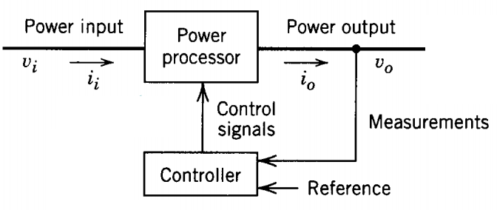
Fig.1.1. Power Electronic System

A power electronic system shown in Fig.1.1 consists of power electronic switching devices, linear circuit elements, digital circuits, microprocessors, electromagnetic devices, DSPs, filters, controllers, sensors, etc….

APPLICATIONS OF POWER ELECTRONICS:

1. Commercial Applications
Heating Systems Ventilating, Air Conditioners, Central Refrigeration, Lighting, Computers and Office equipments, Uninterruptible Power Supplies (UPS), Elevators, and Emergency Lamps.

2. Domestic Applications
Cooking Equipments, Lighting, Heating, Air Conditioners, Refrigerators & Freezers, Personal Computers, Entertainment Equipments, UPS.

3. Industrial Applications
Pumps, compressors, blowers and fans. Machine tools, arc furnaces, induction furnaces, lighting control circuits, industrial lasers, induction heating, welding equipments.

- Aerospace Applications
Space shuttle power supply systems, satellite power systems, aircraft power systems.

- Telecommunications
Battery chargers, power supplies (DC and UPS), mobile cell phone battery chargers.
- Transportation
Traction control of electric vehicles, battery chargers for electric vehicles, electric
locomotives, street cars, trolley buses, automobile electronics including engine controls.

POWER SEMICONDUCTOR DEVICES
The power semiconductor devices classification as shown in Fig.1.2 are used as on/off switches in power control circuit. These devices are classified as follows.
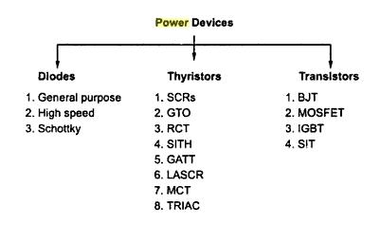

Fig.1.2. Classification of Power Semiconductor Devices

THYRISTOR or SILICON CONTROLLED RECTIFIER (SCR):
The SCR has 3- terminals namely: Anode (A), Cathode (k) and Gate (G) shown in Fig.1.3 (a). Internally it is having 4-layers p-n-p-n as shown in Fig.1.3 (b).
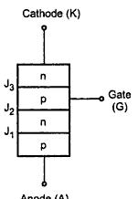
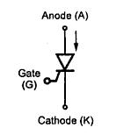

Fig.13 (a) Symbol Fig.13 (b) Structure of SCR

The word thyristor is coined from thyratron and transistor. It was invented in the year 1957 at Bell Labs. The Thyristors can be subdivided into different types
- Forced-commutated Thyristors (Inverter grade Thyristors)
- Line-commutated Thyristors (converter-grade Thyristors)
- Gate-turn off Thyristors (GTO).
- Reverse conducting Thyristors (RCT’s).
- Static Induction Thyristors (SITH).
- Light activated silicon controlled rectifier (LASCR) or Photo SCR’s.
- MOS-Controlled Thyristors (MCT’s).

Silicon Controlled Rectifier (SCR) Thyristor:
The SCR is a four layer P-N-P-N three terminal silicon device with junctions J₁, J₂, J₃ as shown in Fig 1.4. The layers are formed by diffusion or alloying. The inner two layers are lightly dopped and the outer two layesrs are heavily dopped.

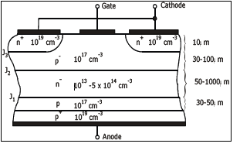

Fig.1.4 Structure of a generic thyristor
SCR operation
Forward blocking Mode:
The simplified model of a thyristor and V-I characteristics are shown in Fig 1.5.and Fig.1.7. When the anode is made positive with respect the cathode junctions J₁&J₃ are forward biased and junction J₂ is reverse biased. With anode to cathode voltage V_{AK}, only forward leakage current flows through the device. The SCR is then said to be in the forward blocking state.
If V_{AK} is further increased to a large value, the reverse biased junction J₂ will breakdown due to avalanche effect resulting in a large current through the device. The voltage at which this phenomenon occurs is called the forward breakdown voltage V_{BO}. Since the other junctions J₁&J₃ are already forward biased, there will be free movement of carriers across all three junctions resulting in a large forward anode current. This is not suggestible method. Once the SCR is switched on, the voltage drop across it is very small, typically 1 to 1.5V. The anode current is limited only by the external impedance present in the circuit.

Fig. 1.5: Simplified model of a thyristor

SCR can be turned on with Gate signal:
SCR can be turned on by applying a positive voltage between gate and cathode as shown in Fig.1.6. With the application of positive gate voltage, leakage current through the junction J₂ is increased. This is because the resulting gate current consists mainly of electron flow from cathode to gate. Since the bottom end layer is heavily doped as compared to the p-layer, due to the applied voltage, some of these electrons reach junction J₂ and add to the minority carrier concentration in the p-layer. This raises the reverse leakage current and results in breakdown of junction J₂ even though the applied forward voltage is less than the breakdown voltage V_{BO}. With increase in gate current breakdown occurs earlier.
If a positive gate current is applied to a thyristor then the transition or break over to
the ON state will occur at smaller values of anode to cathode voltage as shown Fig.1.8.

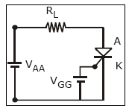
Fig.1.6. Circuit
Fig.1.7: V-I Characteristics

Fig.1.8: Effects on gate current on forward blocking voltage

Reverse blocking Mode
When the anode is made negative with respect the cathode junctions J₁&J₃ are reverse biased and junction J₂ is forward biased. With anode to cathode voltage (-V_{AK}), only reverse leakage current flows through the device. The SCR is then said to be in the reverse blocking state.
If -V_{AK} is further increased to a large value, the reverse biased junctions J₁ & J₃ will breakdown due to avalanche effect resulting in a large current through the device. The voltage at which this phenomenon occurs is called the reverse breakdown voltage V_{RBO.} These are all shown in fig. 1.7.

Holding Current I_{H}
This is the minimum value of anode current to maintain SCR in on state.

Latching Current IL
This is the minimum value of anode current required to maintain SCR in on state at the time of triggering.

SWITCHING or DYNAMIC or ON-OFF CHARACTERISTICS OF SCR

Turn ON Time of SCR
The turn ON and OFF characteristics are shown in Fig.1.9. A forward biased thyristor can be turned on by applying a positive voltage between gate and cathode terminal. But it takes some transition time to go from forward blocking mode to forward conduction mode. This transition time is called turn on time of SCR and it can be subdivided into three small intervals as delay time (t_{d}) rise time (t_{r}), spread time (t_{s}).

Delay Time of SCR
It can be defined as the time taken by the gate current to increase from 90% to 100% of its final value I_{g}. From another point of view, delay time is the interval in which anode current rises from forward leakage current to 10% of its final value and at the same time anode voltage will fall from 100% to 90% of its initial value V_{A.}

Rise Time of SCR
Rise time of SCR in the time taken by the anode current to rise from 10% to 90% of its final value. At the same time anode voltage will fall from 90% to 10% of its initial value V_{A.}
The phenomenon of decreasing anode voltage and increasing anode current is entirely dependent upon the type of the load. For example if we connect a inductive load, voltage will fall in a faster rate than the current increasing. This is happened because induction does not allow initially high voltage change through it. On the other hand if we connect a capacitive load it does not allow initial high voltage change through it, hence current increasing rate will be faster than the voltage falling rate.

Spread Time of SCR
It is the time taken by the anode current to rise from 90% to 100% of its final value. At the same time the anode voltage decreases from 10% of its initial value to smallest possible value. In this interval of time conduction spreads all over the area of cathode and the SCR will go to fully ON State. Spread time of SCR depends upon the cross-sectional area of cathode.

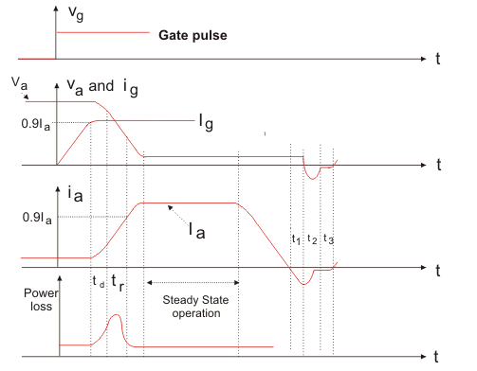

Fig.1.9 Switching characteristics of SCR

Turn OFF Time of SCR
Once the thyristor is switched on or in other point of view, the anode current is above Latching current, the gate losses control over it. That means gate circuit cannot turn off the device. For turning off the SCR anode current must fall below the holding current. After anode current fall to zero we cannot apply forward voltage across the device due to presence of carrier charges into the four layers. So we must sweep out or recombine these charges to proper turn off of SCR.
So turn off time of SCR can be defined as the interval between anode current falls to zero and device regains its forward blocking mode. On the basis of removing carrier charges from the four layers, turn off time of SCR can be divided into two time regions,
- Reverse Recovery Time.
- Gate Recovery Time

Reverse Recovery Time
It is the interval in which change carriers remove from J₁, and J₃ junction. At time t₁, Anode current falls to zero and it will continue to increase in reverse direction with same slope (di/dt) of the forward decreasing current. This negative current will help to sweep out the carrier charges from junction J₁ and J₃. At the time t₂ carrier charge density is not sufficient to maintain the reverse current, hence after t₂ this negative current will start to decrease. The value of current at t₂ is called reverse recovery current. Due to rapid decreasing of anode current, a reverse spike of voltage may appear across the SCR. Total recovery time t3 - t₁ is called reverse recovery time. After that, device will start to follow the applied reverse voltage and it gains the property to block the forward voltage.

Gate Recovery Time
After sweeping out the carrier charges from junction J₁ and J₃ during reverse recovery time, there still remain trapped charges in J₂ junction which prevent the SCR from blocking the forward voltage. These trapped charges can be removed by recombination only and the interval in which this recombination is done, called gate recovery time.

Thyristor Gate Characteristics
Fig. 1.10 shows the gate trigger characteristics.
The gate voltage is plotted with respect to gate current in the above characteristics. Ig(max) is the maximum gate current that can flow through the thyristor without damaging it Similarly Vg(max) is the maximum gate voltage to be applied. Similarly Vg (min) and Ig(min) are minimum gate voltage and current, below which thyristor will not be turned-on. Hence to turn-on the thyristor successfully the gate current and voltage should be

Ig(min) < Ig < Ig(max)
Vg (min) < Vg < Vg (max)
Fig.1.10 Gate Characteristics of SCR
The characteristic of Fig. 1.10 also shows the curve for constant gate power (Pg). Thus for reliable turn-on, the (Vg, Ig) point must lie in the shaded area in Fig. 1.10. It turns-on thyristor successfully. Note that any spurious voltage/current spikes at the gate must be less than Vg (min) and Ig(min) to avoid false triggering of the thyristor. The gate characteristics shown in Fig. 1.10 are for DC values
of gate voltage and current.

Pulsed Gate Drive
Instead of applying a continuous (DC) gate drive, the pulsed gate drive is used. The gate voltage and current are applied in the form of high frequency pulses. The frequency of these pulses is upto l0 kHz. Hence the width of the pulse can be upto 100 micro seconds. The pulsed gate drive is applied for following reasons (advantages):
- The thyristor has small turn-on time i.e. upto 5 microseconds. Hence a pulse of gate
drive is sufficient to turn-on the thyristor.
- Once thyristor turns-on, there is no need of gate drive. Hence gate drive in the form
of pulses is suitable.
- The DC gate voltage and current increases losses in the thyristor. Pulsed gate drive
has reduced losses.
- The pulsed gate drive can be easily passed through isolation transformers to isolate
thyristor and trigger circuit.

Requirement of Gate Drive
The gate drive has to satisfy the following requirements:
- The maximum gate power should not be exceeded by gate drive, otherwise thyristor
will be damaged.
- The gate voltage and current should be within the limits specified by gate characteristics (Fig.1.10) for successful turn-on.
- The gate drive should be preferably pulsed. In case of pulsed drive the following relation must be satisfied: (Maximum gate power x pulse width) x (Pulse frequency) ≤ Allowable average gate power
- The width of the pulse should be sufficient to turn-on the thyristor successfully.
- The gate drive should be isolated electrically from the thyristor. This avoids any damage to the trigger circuit if in case thyristor is damaged.
- The gate drive should not exceed permissible negative gate to cathode voltage, otherwise the thyristor is damaged.
- The gate drive circuit should not sink current out of the thyristor after turn-on.

Triggering Methods

What is triggering:
Triggering is a process by which thyristor or SCR is brought to the conducting state or
switched ON.
The most used methods for triggering an SCR or thyristor are mentioned below:
- Voltage triggering:
The method of triggering in which the triggering of SCR or thyristor is caused by the applied voltage across anode and cathode terminals, is known as Voltage triggering.
When a thyristor is in forward biased and applied voltage across anpde and cathode is increased, then the depletion layer of reverse biased junction decreased. At breakdown voltage, the depletion layer is totally destroyed and as a result the thyristor triggers and comes to ON state and start conducting heavily due to increase in number of charge carriers.
Because this triggering is caused by Voltage, that’s why it’s called Voltage triggering.

- Thermal Triggering
The triggering method in which triggering is caused by the thermal effect i.e. by increasing the junction temperature is called Thermal triggering.
We know that conductivity of semi-conductor materials increases with increase in temperature. Here we make use of this property. When the junction is reverse biased and the applied voltage across anode and cathode is near to breakdown voltage then we increases the temperature of the junction as a result the due to formation of electron-hole pairs, the thyristor starts conducting
In this case we should not increase the temperature to a high value, because this may cause damage to device. So, in this method the SCR or thyristor is triggered by thermal properties, therefore it is called thermal Triggering.

- RadiationTriggering :
The method in which the triggering of a SCR or thyristor is caused by radiation i.e. by the bombardment of energy particles, for example Neutrons, photons etc.
In this method the triggering is done with the help of Radiation or by bombardment of energy particles. The thyristor is bombarded by energy particles like neutrons or photons. Due to the radiation, the electron-hole pairs are generated in the device. These pairs cause the flow of current in the device. Thus thyristor comes to ON state and hence triggered.

- dv/dttriggering
The triggering method in which we make use of high rate of increase of voltage(or dv/dt i.e. rate of change of voltage with respect to time). When a thyristor is optimised for a critical rate of rise of voltage, then if the rate of rise of voltage increases, the thyristor will be triggered and start conducting.

- GateTriggering:
The triggering method in which triggering of SCR or thyristor is caused by applying a signal between gate and cathode, is called Gate triggering.
Gate triggering is mostly used method for triggering an SCR or thyristor. This method is used in almost all industries and laboratories to trigger thyristor. In this method a positive signal is applied in between gate and cathode terminal. By using this method we can trigger the device much before its breakdown voltage. Hence, we can also control the firing angle (α) and the conduction angle (γ=180-α) of SCR or thyristor.

Two Transistor Model of SCR

Basic operating principle of SCR can be easily understood by the two transistor model of SCR or analogy of silicon controlled rectifier, as it is also a combination of P and N layers, shown in Fig.1.11 below. This is a PNPN thyristor. The equivalent circuit of Two transistor model of SCR is shown in Fig.1.12. If we bisect it through the dotted line then we will get two transistors i.e. one PNP transistor with J₁ and J₂ junctions and another is with J₂ and J₃ junctions as shown in Fig.1.11 below

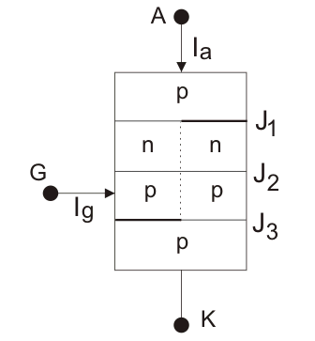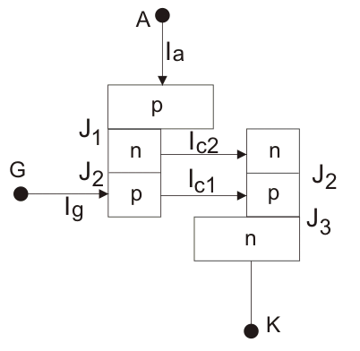
Fig.1.11 Two Transistor Model of SCR

When the transistors are in off state, the relation between the collector current and emitter
current is shown below

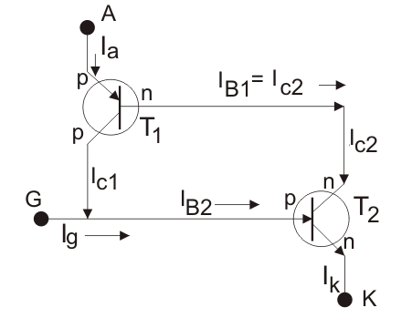
Fig.1.12 Equivalent circuit for two transistor model of SCR

Here, I_{C} is collector current, I_{E} is emitter current, I_{CBO} is forward leakage current, α is common base forward current gain and relationship between I_{C} and I_{B} is
Where, I_{B} is base current and β is common emitter forward current gain. Let’s for transistor T₁ this relation holds
and that for transistor T₂
Now, by the analysis of two transistors model we can get anode current,
From equation (i) and (ii), we get,
If applied gate current is I_{g} then cathode current will be the summation of anode current and gate current i.e.
By substituting this value of I_{k} in (iii) we get,
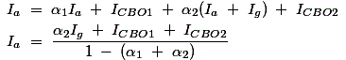
From this relation we can assure that with increasing the value of (α₁ + α₂) towards unity, corresponding anode current will increase. Now the question is how (α₁ + α₂) increasing? Here is the explanation using two transistor model of SCR. At the first stage when we apply a gate current I_{g}, it acts as base current of T,₂ transistor i.e. I_{B2} = I_{g} and emitter current i.e. I_{k} = I_{g} of the T,₂ transistor. Hence establishment of the emitter current gives rise α₂ as
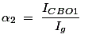
Presence of base current will generate collector current as
This I_{C2} is nothing but base current I_{B1} of transistor T,₁, which will cause the flow of collector current,
I_{C1} and I_{B1} lead to increase I_{C1} as I_{a} = I_{C1} + I_{B1} and hence, α₁ increases. Now, new base current of T₂ is I_{g} + I_{C1} = (1 + β₁β₂)I_{g}, which will lead to increase emitter current I_{k} = I_{g} + I_{C1} and as a result α₂ also increases and this further increases I_{C2} = β₂(1 + β₁β₂)I_{g}. As I_{B1} = I_{C2}, α₁ again increases. This continuous positive feedback effect increases (α₁ + α₂) towards unity and anode current tends to flow at a very large value. The value current then can only be controlled by external resistance of the circuit.

Series and Parallel Connection of thyristors
In some industrial applications the voltage and current levels are in excess of a single available thyristor. In such cases series / parallel connection of multiple thyristors are employed. For series or parallel connected thyristors it should be ensured that each thyristor rating is utilized fully and the system performance is satisfactory. String efficiency is a term used to measure the degree of utilization of thyristors in series / parallel connection and is defined as

For obtaining the highest possible string efficiency the thyristors connected in series / parallel must have identical i-v characteristics. Even then, unequal voltage / current sharing does occur which makes string efficiency lees than unity. However, unequal voltage / current sharing by the thyristors in a string can be minimized to a great extent by using external equalizing circuits.

Series connection of thyristors
V_{A1}
V_{A2}
I_{A}
Th₁
Th₂
(a)
V_{A2}
V_{A1}
V_{AK}
Th₁
Th₂
I_{A}
i_{A}
(b)
Fig.1.13 Series connected SCRs & V-I Characteristics

Fig 1.13 (b) shows the static i-v characteristics of two series connected thyristors of Fig.1.13 (a). It is seen that slight difference in the forward blocking characteristics of the two thyristors results in considerable difference in the forward voltage blocked by each thyristor. Similar difference will be found for reverse blocking voltage.
The problem of unequal voltage sharing will be more prominent during dynamic conditions. It is likely that SCRs will not have identical dynamic characteristics. In such cases, series connected SCRs will have unequal voltage distribution during the transient conditions of turn ON and turn OFF.
The below figures of Fig 1.14(a) & (b) shows the individual Turn ON and Turn Off characteristics of series connected thyristors TH₁ and TH₂ of Fig 1.14(b). It is assumed that TH₂ has a larger turn on delay time and larger turn off time. As a result when the series combination of TH₁ and TH₂ are gated together TH₁ turns on faster while the voltage across TH₂ rises to the full supply voltage V_{s}.
During Turn off as the forward current through the series combination goes negative TH₁ recovers earlier blocking the path for reverse recovery of Th₂. Consequently the reverse voltage is supported by TH₁ alone while the voltage across TH₂ remains almost zero.
A simple resistor as shown in Fig 1.15 will not ensure equal voltage distribution across devices during dynamic condition. The reverse biased junctions of thyristor are likely to have different capacitances and when connected in series, are likely to share dynamic voltage unequally during Turn on and Turn off.
This problem can be avoided by connecting shunt capacitors across thyristors as shown in Fig 1.15. These shunt capacitors being much larger than the reverse biased junction capacitors of the thyristors tends to equalize the effective capacitance of the circuit. A series resistance R_{C} is also used along with the shunt capacitance in order to limit the capacitor discharge current during “Turn on” of the thyristor. A diode D by passes R_{C} when forward voltage appears across the series combination. This makes the capacitor more effective for voltage equalization and for limiting across the thyristor.

V_{AK}
V_{AK}
V_{AK}
V_{AK1}
V_{AK1}
V_{AK2}
V_{AK2}
V_{AK2}
V_{AK1}
V_{S}
V_{S/2}
V_{S}
t
t
t
t
Th₂
Th₁
i_{a}
(a)
(b)

Fig 1.14: Turn ON and Turn OFF characteristics of series connected Thyristors.
  - Turn ON characteristics; (b) Turn OFF characteristics.

R
R
Static voltage equalizer
R_{C}
R_{C}
TH1
TH2
D
D
C
C
A
Dynamic
voltage
equalizer
Fig.1.15 Static and dynamic voltage equalizer for series connected thyristor.

Parallel connection of Thyristors
A number of thyristors are connected in parallel to supply load currents in excess of the individual ratings of the thyristors. For equal sharing of current, the i-v characteristics of parallel connected thyristors should be as for as possible identical. Otherwise difference in current sharing will occurs as shown in Fig 1.16.
TH1
TH2
V_{AK}
I_{a}
I₂
I_{A}
I₁
(a)
TH1
TH2
V_{AK}
V_{AK}
I₁
I₂
(b)
i_{a}
TH2
I₁
TH1
I₂
A
K
(c)
Fig.1.16: Current sharing of parallel connected thyristors.

In this case TH₁ has a lower voltage drop and hence it shares larger current. Difference in current sharing may occur due to difference in the dynamic characteristics of the thyristors. For example, if one of the thyristors have a larger turn on delay time compared to other thyristors with which it is parallel it will not turn on at the same instant as the other thyristors turn ON. However, voltage across it will collapse due to turning ON of other thyristors. For a given gate current a minimum anode cathode voltage is required for a thristor to turn ON which may not be available in this case. Thus the thyristor with larger turn
ON delay time will never turn ON.
Unequal current sharing also causes unequal heating of thyristor junctions. The ON state voltage drop across a conducting thyristor is a strong function of the junction temperature and decreases with increasing junction temperature. Thus the thyristor carrying the largest current tend to share even more current as its junction temperature rises. This may lead to “thermal run away” and destroy all parallels connected thyristors. In an ac circuit unequal current sharing between parallel connected thyristors can be avoided by using a reactor as shown in Fig 1.16 (c). The reactor offers little impedance to the common mode current (I₁ + I₂) but a large impedance to any circulating current (I₁ – I₂). Unequal current sharing is thus minimized.

Thyristor Protection
In a converter circuit a thyristor circuit needs to be protected against
- Large, (ii) Large, (iii) Over voltage and (iv) Over current.
In addition the thyristor gate circuit also needs to be protected against over voltage over current and spurious noise signals. Fig.1.17. shows typical protection arrangement of thyristor for all the cases.

Protection:
As discussed in connection with turn on switching of a thyristor, the anode current, just after turn on is restricted to a small area of the cathode which increases with time at a finite rate. Now if the rate of rise of anode current is larger than that rate the current density in a portion of the cathode cross section will keep on increasing leading to the formation of local hot spots. The device may be destroyed in the process. The manufacturers usually specify a limiting value of (20-500 A/μs) which should not be exceed to avoid this type of failure. In a thyristor converter circuit the rate of rise of anode current is restricted by connecting on inductor of appropriate value in series with the thyristor. This is called the limiting inductor.

protection:
When a forward voltage is suddenly applied across reverse biased thyristor there will be considerable redistribution of minority carriers across all three junctions. The process is akin to charging the junction capacitances with the opposite polarity. If the rate of change of the applied is large this “capacitor charging current” across the junctions may become sufficient to satisfy the latching condition of the thyristor (i.e, ∝1 + ∝2 = 1) and
the thyristor may turn on even in the absence of a gate pulse. To protect against such spurious turn on of the thyristor a properly designed RC snubber circuit (as discussed in connection with diode circuit) should be used across the thyristor. The snubber components should be designed such that they along with the limiting inductor and the load forms a slightly under damped circuit.

Over voltage protection:
Over voltage across a thyristor may occur due to several reasons such as due to snappy reverse recovery, due to commutation in other thyristors in the same circuit, network switching, lightning surges etc. Of these, the first two types can be handled by a properly designed snubber circuit across the thyristor. However, for the last two types, over voltage protection of a thyristor must be upgraded by using a voltage clamp device across the thyristor.
A voltage clamp device is a non linear resistance which acts as an open circuit under normal condition (i.e. below clamping voltage) and as a short circuit when voltage cross it crosses the clamping level. The surge energy is dissipated in the non linear resister. Metal oxide Varistors are commonly used as voltage clamp devices.

Over current protection:
Over current in a thyristor circuit occurs due to a fault or short circuit. Thyristor can with stand fault currents far in excess of its rated average or RMS forward current for short durations (several cycles of the supply frequency). Therefore, if the fault impedance is high or the supply ac network has a relatively low short circuit level, the thyristor may be protected using a normal circuit breaker. However, for a short circuit fault when the ac network supplying the thyristor circuit is stiff the fault current may rise to dangerous level and destroy the device. To protect a thyristor against such faults Fast Acting Current Limiting Fuse (F.A.C.L fuse) is connected in series with a thyristor. For proper protection co-ordination of the fuse and the thyristor is important. The i²t rating of the fuse must be less than that of the thyristor and the “peak let through current” should be less than the sub cycle surge current rating of the thyristor. The fuse voltage rating should also be less than the surge voltage rating of the thyristor.

Gate protection:
The gate circuit should be protected against over voltage and over current. A series resistance and a zener diode across the gate cathode terminals are provided for this purpose. To prevent conducted or radiated EMI to affect the gate circuit the gate supply cables are twisted and shielded. In addition, a small capacitor (a few hunded nF) in parallel with another resistance is connected just across the gate and cathode terminals to protect the gate against spurious noise voltages. In very large power application Light activated Thyristors using optical fiber signal transmission is used for maximum protection against spurious turn on.

From
Supply
Circuit
Breaker
F.A.C.L
Fuse
R.C snubber
di/dt limiting
inductor
Voltage clamp device (MOV)
Gate pulse

To
LOAD
Fig. 1.17: Thyristor protection circuit.

R.C snubber
RC snubber circuit is shown in Fig 1.18
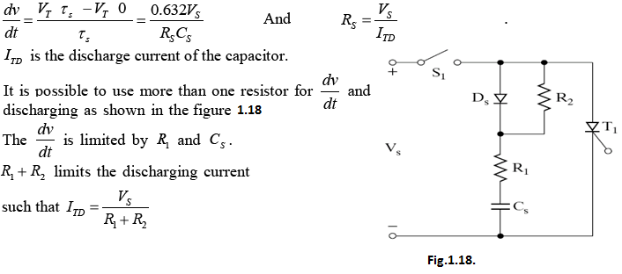
di/dt limiting inductor
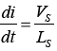

Rating of SCR or Thyristor
Thyristor ratings or SCR ratings are very much required for operating it in a safe zone. The reliable operation can be done when a thyristor does not violate its voltage and current rating during working period. A thyristor, or SCR may have several ratings, such as voltage, current, power, dv/dt, di/dt, turn on time, turn off time, etc. Generally these ratings are specified in the data sheet given by manufacturer.

Anode Voltage Rating
This rating gives us a brief idea about withstanding power of a thyristor in forward blocking made in the absence of gate current.

Peak Working Forward Blocking or Forward OFF State Voltage (V_{DWM})
It specifies the maximum forward voltage (positive voltage that applied across anode and cathode) that can be withstand by the SCR at the time of working.

Peak Repetitive Forward Blocking Voltage (V_{DRM})
It specifies the peak forward transient voltage that a SCR can block repeatedly or periodically in forward blocking mode. This rating is specified at a maximum allowable junction temperature with gate circuit open. During commutation process, due to high decreasing rate of reverse anode current a voltage spike Ldi/dt is produced which is the cause of V_{DRM} generation.

Peak Non-Repetitive or Surge Forward Blocking Voltage (V_{DSM})
It is the peak value of the forward transient voltage that does not appear periodically. This type of over voltage generated at the time of switching operation of circuit breaker. This voltage is 130 % of V_{DRM}), although it lies under the forward break over voltage (V_{BD}). Peak Working Revere Voltage (V_{RWM})
It is the maximum reverse voltage (anode is negative with respect to cathode) which can be withstand by the thyristor repeatedly or periodically. It is nothing but peak negative value of the AC sinusoidal voltage.

Peak Repetitive Revere Voltage (V_{RRM})
It is the value of transient voltage that can be withstand by SCR in reverse bias at maximum allowable temperature. This reason behind the appearance of this voltage is also same as V_{DRM}.

Peak Non Repetitive Revere Voltage (V_{RSM})
It implies the reverse transient voltage that does not appear repetitively. Though this voltage value is 130% of V_{RRM}, it lies under reverse break over voltage, V_{BR}.

Forward ON State voltage Drop (V_{T})
This is the voltage drop across the anode and cathode when rated current flows through the SCR at rated junction temperature. Generally this value is lie between 1 to 1.5 volts.

Forward dv/dt Rating
When we apply a forward voltage to the thyristor Junction J₁ and J₃ are forward biased whereas junction J₂ is reverse biased and hence it acts a capacitor. So due to Cdv/dt a leakage current flows through the device. This value of current will increase with the value of dv/dt. One thing we have to keep in mind that voltage value is not the reason behind flowing of leakage current, the reason is the rate of voltage increasing. The value of capacitance of the junction is constant hence when dv/dt increases to a suitable value that leakage current occurs an avalanche breakdown across junction J₂. This value of dv/dt in called forward dv/dt rating which can turn on the SCR without help of gate current. In practice it is not suitable to applyhigh dv/dt due to high temperature malfunction of SCR.

Voltage Safety Factor of SCR (V_{SF})
It is described as the ratio of peak repetitive reverse voltage (V_{RRM}) to the maximum value of input voltage.
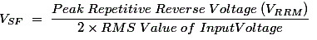

Finger Voltage of SCR (V_{FV})
It is the minimum value of voltage which must be applied between anode and cathode for turning on the device by gate triggering. Generally this voltage value is little more than normal ON state voltage drop.

Current Rating of SCR
We all know that a thyristor, hence a SCR is made of semiconductor which is very much thermal sensitive. Even due to short time over current, the temperature of the device may rise to such a high value that it may cross its maximum allowable limit. Hence there will be a high chance of permanent destruction of the device. For this reason, current rating of SCR is very essential part to protect the SCR.

Maximum RMS Current Rating (I_{RMS})
Generations of heat in the device present where resistive elements are present in the device. Resistive elements such as metallic joints are totally dependent upon rms current as power loss is I_{RMS}²R, which is converts to heat, hence cause of temperature rise of the device Hence, I_{RMS} rating of the thyristor must be a suitable value so that maximum heat capability of SCR cannot exceed.

Maximum Average Current Rating (I_{AV})
It is the allowable average current that can be applied safely such that maximum junction temperature and rms current limit cannot be exceeded. Generally manufacturer of SCR provides a characteristic diagram which shows I_{AV} as a function of the case temperature I_{C} with the current conduction angle φ as a parameter. This characteristic is known as "forward average current de-rating characteristic".

Maximum Surge Current (I_{SM})
If a thyristor operates under its repetitive voltage and current ratings, its maximum allowable temperature is never exceeded. But a SCR may fall into a abnormal operating condition due to fault in the circuit. To overcome this problem, a maximum allowable surge current rating is also specified by manufacturer. This rating specifies maximum non repetitive surge current that the device can withstand. This rating is specified dependent upon the number of surge cycle. At the time of manufacturing at least three different surge current ratings for different durations are specified. For example, I_{SM} = 3,000A for 1/2 cycle I_{SM} = 2,100A for 3 cycles I_{SM} = 1,800A for 5 cycles A plot between I_{SM} and cycle numbers are also provided for dealing with the various cycle surge current.

I²t Rating of SCR
This rating is provided to get an idea about over-voltage tackle power of a thyristor. The rating in term of A²S is the measure of energy that can be handled by a thyristor for a short while. An electrical fuse I²t rating must be less than that of thyristor to be used to protect it.

di/dt Rating of SCR
While, SCR is getting turn on, conduction stays in a very small area nearer to the gate. This small area of conduction spreads throughout the whole area of the junctions. But if spreading velocity of the charge carriers will be smaller than the di/dt then local hot spot may arise nearer to the gate which may destroy the device. To overcome this problem a maximum rate of rise of current, di/dt is also specified during manufacturing of the devices.

Latching Current of Thyristor
This is the rating of current below which the SCR can't be turned on even the gate signal is applied. That means this much anode current must rise to turn on the device. The gate pulse must be continuous until anode current is greater or equal to latching current of thyristor otherwise the device will fail to be turned on.

Holding Current of Thyristor
This is the rating of current below, which anode current must fall to turn off the device.

Gate Specification of SCR

Gate Current to Trigger (I_{GT})
This is the value of gate current below which device cannot be turned on. This value of current specified at a particular forward break down voltage.

Gate Triggering Voltage (V_{GT})
This is the value of minimum gate voltage that must be a acquired by the gate circuit for proper turn on of the SCR. This voltage value is also specified at a particular forward breakdown voltage similar to I_{GT}.

Non Triggering Gate Voltage (V_{NG})
This is the maximum value of gate circuit source voltage below which the device must be in off state. All unwanted noise signals must lie under this voltage to avoid unwanted turn on of the device.

Peak Reverse Gate Voltage (V_{GRM})
This is the value of maximum reverse voltage which can be applied across the cathode and gate.

Average Gate Power Dissipation (P_{GAR})
This is the value of average power dissipation which cannot be exceeded by a gate circuit for a gate current pulse wider than 100 microseconds.

Peak Forwarded Gate Current (I_{GRM})
This is the rating of maximum forward gate current that should not be exceeded to reliable and safe operation.

SCR Turn OFF or Commutation Methods
The reverse voltage which causes to commutate the SCR is called commutation voltage. Depending on the commutation voltage located, the commutation methods are classified into two major types.
Those are 1) Forced commutation and 2) Natural commutation. Let us discuss in brief about these methods.

Natural Commutation
In natural commutation, the source of commutation voltage is the supply source itself. Fig1.19 shows natural commutation and related wave forms. If the SCR is connected to an AC supply, at every end of the positive half cycle the anode current goes through the natural current zero and also immediately a reverse voltage is applied across the SCR. These are the conditions to turn OFF the SCR.
This method of commutation is also called as source commutation, or line commutation, or class F commutation. This commutation is possible with line commutated inverters, controlled rectifiers, cyclo converters and AC voltage regulators because the supply is the AC source in all these converters.
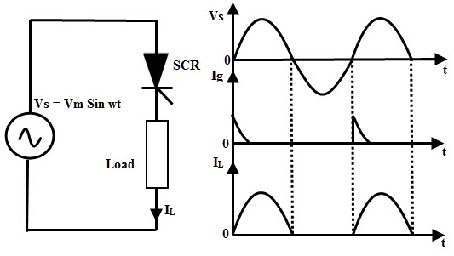
Fig.1.19 Natural commutation circuit and Related wave forms

Forced Commutation
In case of DC circuits, there is no natural current zero to turn OFF the SCR. In such circuits, forward current must be forced to zero with an external circuit to commutate the SCR hence named as forced commutation.
This commutating circuit consist of components like inductors and capacitors called as commutating components. These commutating components cause to apply a reverse voltage across the SCR that immediately bring the current in the SCR to zero.
Based on the manner in which the zero current achieved and arrangement of the commutating components, forced commutation is classified into different types such as class A, B, C, D, and E. This commutation is mainly used in chopper and inverter circuits
.

Class A Commutation
This is also known as self commutation, or resonant commutation, or load commutation. In this commutation, the source of commutation voltage is in the load. This load must be an under damped R-L-C supplied with a DC supply so that natural zero is obtained.
The commutating components L and C are connected either parallel or series with the load resistance R as shown in Fig.1.20 with waveforms of SCR current, voltage and capacitor voltage.
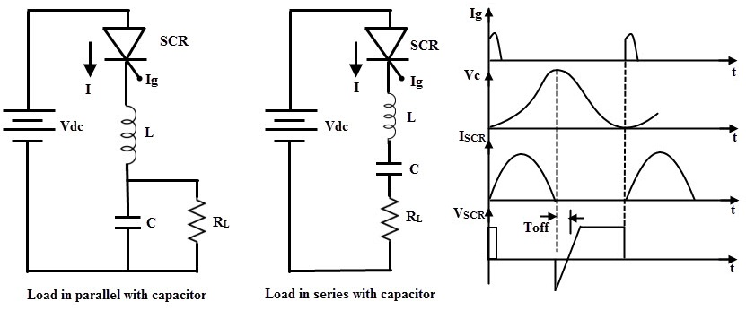
Fig.1.20 Class A Commutation Circuit and related wave forms
The value of load resistance and commutating components are so selected that they forms a under damped resonant circuit to produce natural zero. When the thyristor or SCR is triggered, the forward currents starts flowing through it and during this the capacitor is charged up to the value of E.
Once the capacitor is fully charged (more than the supply source voltage) the SCR becomes reverse biased and hence the commutation of the device. The capacitor discharges through the load resistance to make ready the circuit for the next cycle of operation. The time for switching OFF the SCR depends on the resonant frequency which further depends on the L and C components.
This method is simple and reliable. For high frequency operation which is in the range above 1000 Hz, this type of commutation circuits is preferred due to the high values of L and C components.

Class B Commutation
This is also a self commutation circuit in which commutation of SCR is achieved automatically by L and C components, once the SCR is turned ON. In this, the LC resonant circuit is connected across the SCR but not in series with load as in case of class A commutation and hence the L and C components do not carry the load current. Fig1.21 shows class B commutation and related wave forms.
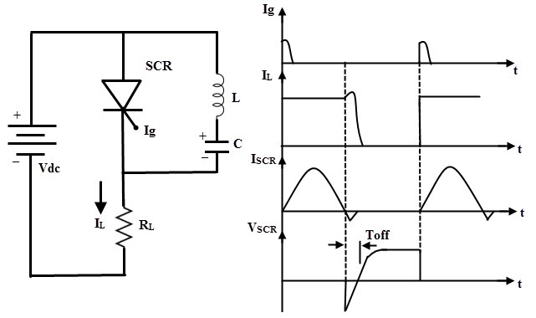
Fig.1.21 Class B Commutation Circuit and related wave forms
When the DC supply is applied to the circuit, the capacitor charges with an upper plate positive and lower plate negative up to the supply voltage E. When the SCR is triggered, the current flows in two directions, one is through E+ – SCR – R – E- and another one is the commutating current through L and C components.
Once the SCR is turned ON, the capacitor is starts discharging through C+ – L – T – C-. When the capacitor is fully discharged, it starts charging with a reverse polarity. Hence a reverse voltage applied across the SCR which causes the commutating current IC to oppose load current IL.
When the commutating current Ic is higher than the load current, the SCR will automatically turn OFF and the capacitor charges with original polarity.
In the above process, the SCR is turned ON for some time and then automatically turned OFF for some time. This is a continuous process and the desired frequency of ON/OFF depends on the values of L and C. This type of commutation is mostly used in chopper circuits.

Class C Commutation
In this commutation method, the main SCR is to be commutated is connected in series with the load and an additional or complementary SCR is connected in parallel with main SCR. This method is also called as complementary commutation.
In this, SCR turns OFF with a reverse voltage of a charged capacitor. The Fig.1.22 shows the complementary commutation with appropriate waveforms.
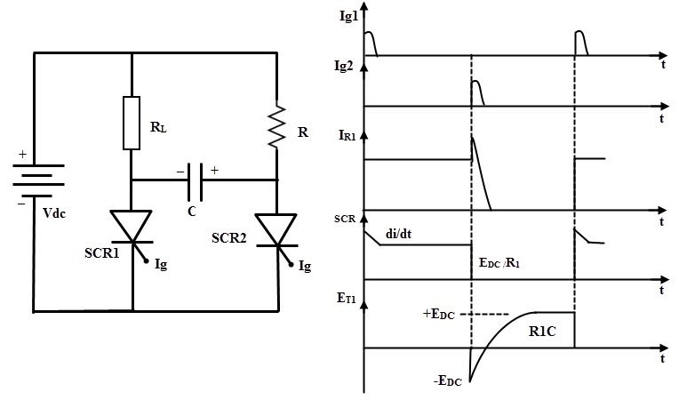
Fig.1.22 Class C Commutation Circuit and related wave forms

Initially, both SCRs are in OFF state so the capacitor voltage is also zero. When the SCR1 or main SCR is triggered, current starts flowing in two directions, one path is E+ – R1 – SCR1 – E- and another path is the charging current E+ – R2- C+ – C- SCR1 – E- . Therefore, the capacitor starts charging up to the value of E.
When the SCR2 is triggered, SCR is turned ON and simultaneously a negative polarity is applied across the SCR1. So this reverse voltage across the SCR1 immediately causes to turn OFF the SCR1. Now the capacitor starts charging with a reverse polarity through the path of E+ – R1- C+ – C- SCR2 – E-. And again, if the SCR 1 is triggered, discharging current of the capacitor turns OFF the SCR2.
This commutation is mainly used in single phase inverters with a centre tapped transformers. The Mc Murray Bedford inverter is the best example of this commutation circuit. This is a very reliable method of commutation and it is also useful even at frequencies below 1000Hz.

Class D Commutation
This is also called as auxiliary commutation because it uses an auxiliary SCR to switch the charged capacitor. Fig.1.23 shows class D commutation with related waveforms. In this, the main SCR is commutated by the auxiliary SCR. The main SCR with load resistance forms the power circuit while the diode D, inductor L and SCR2 forms the commutation circuit.
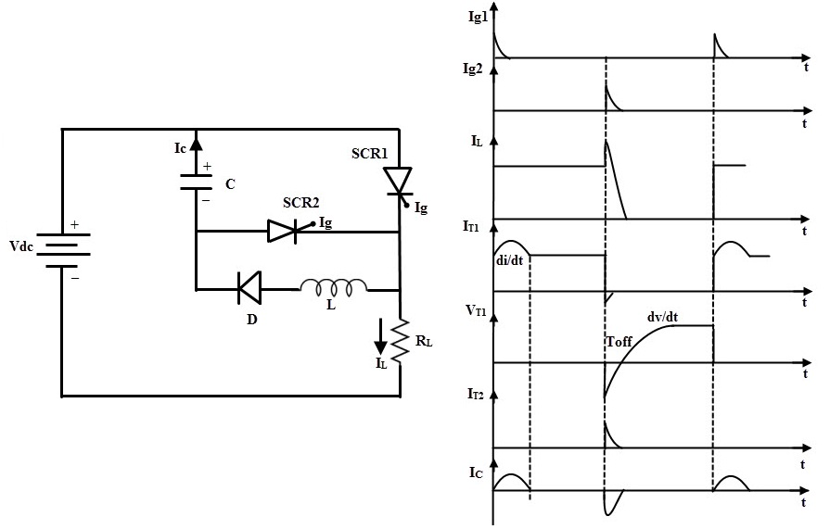
Fig.1.23 Class D Commutation Circuit and related wave forms
When the supply voltage E is applied, both SCRs are in OFF state and hence the capacitor voltage is zero. In order to charge the capacitor, SCR2 must be triggered first. So the capacitor charges through the path E+ – C+ – C- – SCR2- R- E-.
When the capacitor is fully charged the SCR2 becomes turned OFF because no current flow through the SCR2 when capacitor is charged fully. If the SCR1 is triggered, the current flows in two directions; one is the load current path E+ – SCR1- R- E- and another one is commutation current path C+ – SCR1- L- D- C.
As soon as the capacitor completely discharges, its polarities will be reversed but due to the presence of diode the reverse discharge is not possible. When the SCR2 is triggered capacitor starts discharging through C+ – SCR2- SCR1- C-. When this discharging current is more than the load current the SCR1 becomes turned OFF.
Again, the capacitor starts charging through the SCR2 to a supply voltage E and then the SCR2 is turned OFF. Therefore, both SCRs are turned OFF and the above cyclic process is repeated. This commutation method is mainly used in inverters and also used in the Jones chopper circuit.

Class E Commutation
This is also known as external pulse commutation. In this, an external pulse source is used to produce the reverse voltage across the SCR. The Fig. 1.24 below shows the class E commutation circuit which uses a pulse transformer to produce the commutating pulse and is designed with tight coupling between the primary and secondary with a small air gap.
If the SCR need to be commutated, pulse duration equal to the turn OFF time of the SCR is applied. When the SCR is triggered, load current flows through the pulse transformer.If the pulse is applied to the primary of the pulse transformer, an emf or voltage is induced in the secondary of the pulse transformer.
This induced voltage is applied across the SCR as a reverse polarity and hence the SCR is turned OFF. The capacitor offers a very low or zero impedance to the high frequency pulse.
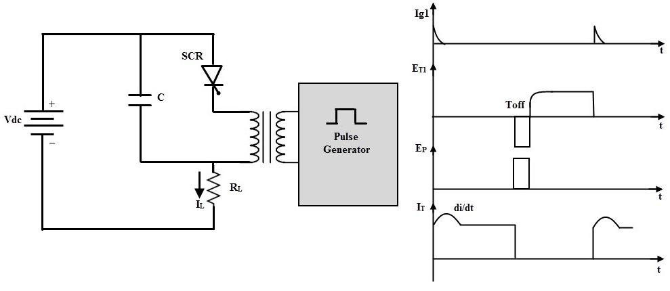
Fig.1.24 Class E Commutation Circuit and related wave forms

